

Workshop on Time Use Surveys
Amman, Jordan, 25- 28 April, 2011

INFORMATION NOTE FOR PARTICIPANTS

I. BACKGROUND
There has been an increasing interest and demand from member countries in conduct time-use survey. The growing interest in time-use survey techniques stems not only from the central and strategic importance of time-use statistics for both policy and research purposes, but also from the versatility and wide range of applications of time-use statistics in numerous areas of policy concern (such as transportation, leisure and recreation, pension plans and health-care programmes etc.). In addition to their early applications in areas such as the study of social change, division of labour, allocation of time for household obligations etc., time-use studies are more recently featured in the estimation of the value of household production. Time-use statistics have been identified as (a) crucial non-monetary data for the “analysis of productive household and leisure activities … and for some instrumental household activities, such as commuting” and (b) a common source using a common unit of measure for fundamental descriptive data not otherwise obtainable on human activities in various fields of social, demographic and related economic statistics.

II. OBJECTIVE
The Workshop objective is to review methods and practices in collecting, processing and disseminating time-use statistics at the regional and international levels, with a main focus on the design and classification issues pertinent to the measurement of paid and unpaid work.

III. PARTICIPANTS

The Workshop will bring together statisticians from national statistical offices in the Arab region.

IV. WORKSHOP VENUE AND ACCOMMODATION
- The Workshop on Time Use Survey will take place from 25-28 April, 2011. In the Workshop, the morning session will be from 9:00 a.m. to 12.00 p.m. and the afternoon session will be from 1:30 p.m. to 5:30 p.m. (Please see attached agenda).

- It will be held at the Sadeen Amman Hotel and Suites at the following address, and contact person:

Wasfi Al-Tal (Gardens) St. – Amman- Khalda  P.O. Box 1852, Amman, 11953, Jordan  Tel: +962 6 5514733  Fax: +962 6 5525762  Email: info@coral-sadeen.com  Website: www.coral-sadeen.com | Mr. Laith Kashkash  Sales Executive  Tel: 00962-6-5514733  Fax: 00962-6-5525762  Mob: 00962- 79 580 1712  Email : laith.kashkash.com  www.coral-sadeen.com

- Group reservation has been made in Sadeen Amman Hotel for all participants. The rates are as follow:
    - Single Room JD 50.000 per night including breakfast
    - Double Room JD 60.000 per night including breakfast
(Above rates does not include 10%service charge and subject to 8% government sales tax)

- The following additional privileges will be offered to the group:
  - Free unlimited internet access
  - Free one small bottle of drinking water daily (rooms)
  - 20% discount on food & beverage at Mood restaurant & Terrace
  - 10% discount for laundry services
  - 10% discount for the Mini bar and room service
  - Free use of the health club

- Please note the normal check in time at Hotel is 2:00 p.m. and checkout time is 12:00 p.m.
- Settlement of invoices for the rooms should be made by the participants directly.

V. WORKSHOP LANGUAGE
There will be simultaneous interpretation provided from/to English/Arabic during the meeting sessions.

VI. TRANSPORTATION
Airport pick-up and drop off is available by the hotel upon request. The current price is JD 30.000 per way by standard sedan car.

VII. MAPS
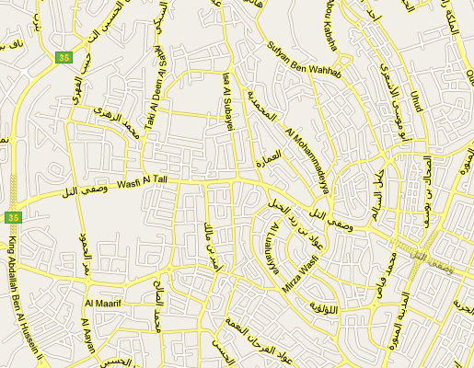

VIII. GENERAL INFORMATION
- For more information please contact the UNESCWA Statistics Division:

Mrs. Amal Nicola
Nicola@un.org
UN House, ESCWA
Tel number: +9611 978 352
Fax number: +9611 981 510

